Jacob Dineen

IST659 DB Admin Lab #10

9/17/2017

1. Code and execute the SQL statements to create the tables in the model above. Note that

**boldface columns** are required and cannot be NULL.

-- Create Tables

Create TABLE Studio (

StudioID int identity primary key

, StudioName char (50) NOT NULL

)

GO

Create TABLE Film (

FilmID int identity primary key

, Title char (50) NOT NULL

, StudioID int FOREIGN KEY REFERENCES Studio(StudioID) NOT NULL

)

GO

Create TABLE Actor (

ActorID int identity primary key

, FirstName char (50) NOT NULL

, LastName char (50) NOT NULL

, DOB datetime

)

GO

Create TABLE FilmCast (

FilmCastID int identity primary key

, FilmID int FOREIGN KEY REFERENCES Film(FilmID) NOT NULL

, ActorID int FOREIGN KEY REFERENCES Actor(ActorID) NOT NULL

)

GO

2. Create an ODBC connection to your IST659 database (containing the tables created above). In

your answer doc, paste a screenshot of the successful connection test. Example:



3. Create a new blank Microsoft Access database and link to the tables you created in Step 1.



4. Under Database Tools, edit the relationships in Access to link the tables together based on the

model at the beginning of the lab. This will aid in Form design later. Paste a screenshot of your

completed Access relationships window to the Answers doc.

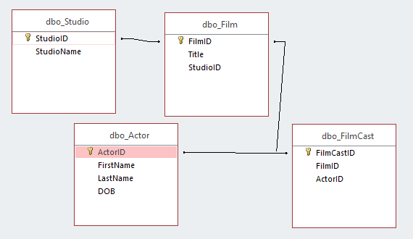

5. Create the following forms. Ensure the form controls for the foreign keys are drop downs that

show the text of the related field. For instance, when selecting a Studio for the Film, store the

StudioID in the database, but be sure the dropdown shows the Studio’s Name to the user. Using

the Form Wizard will help with all of these. Paste a screenshot of each form into your answers

doc.

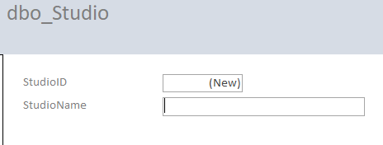

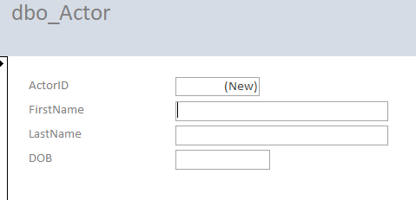

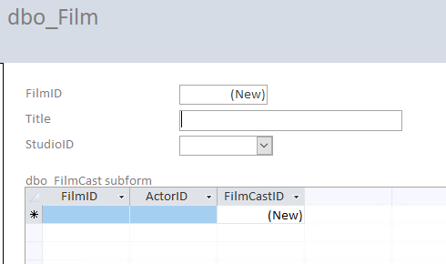

6. Using www.imdb.com, find some real life data to enter into your forms. Find at least 2 film

studios (ie Dreamworks, Pixar, Disney, Universal, etc)to add and at least 5 films from each of

those studios, and the top 5 billed actors for each.

7. Create an Access Report that brings all of these tables together, grouped by Studio, then Film,

then Actor. Paste a screenshot of the first page of your report in your Answers doc.

**For Some Reason, I couldn’t get the below report to accurately populate all of the data from the tables that I inserted in step 6 (Incredibles is stored with studio = Pixar)**: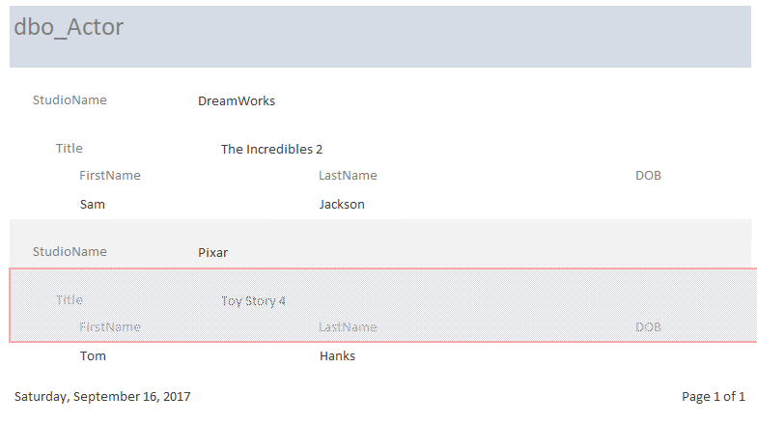

8. In SQL Server management studio, execute the following code and paste a screenshot of the

output to your answers document.

Select

Film.Title

, Actor.FirstName

, Actor.LastName

From FilmCast

INNER JOIN Film ON Film.FilmID = FilmCast.FilmID

INNER JOIN Actor ON Actor.ActorID = FilmCast.ActorID

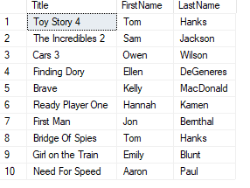

Running the concatenated name line:

Select

Film.Title

, Actor.FirstName & ' ' & Actor.LastName as ActorName

From FilmCast

INNER JOIN Film ON Film.FilmID = FilmCast.FilmID

INNER JOIN Actor ON Actor.ActorID = FilmCast.ActorID

Returns:

